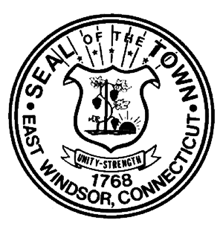

TOWN OF EAST WINDSOR
SPECIAL TOWN MEETING

The legal voters of the Town of East Windsor are hereby warned that a special town meeting will be held at the Town Hall, 11 Rye Street, Broad Brook, CT on September 21, 2010 at 7:30 p.m. for the following:

- To transfer $40,000.00 from Contingency (8410/890) to Capital Improvement Current/ P. Works- East Road Bridge (9445/0646) in the 2010/2011 budget.
- To transfer $4,091.00 from Town Clerk/Salary FT (1030-100) to Town Clerk/Salary P/T (1030/101) in the 2009/2010 budget.

Dated at East Windsor, Connecticut this 15th day of September 2010.

EAST WINDSOR BOARD OF SELECTMEN

_________________________________
Denise Menard, First Selectman

_________________________________

Mark Simmons, Deputy First Selectman

_________________________________
John L. Burnham, Selectman

_________________________________

Gilbert R. Hayes, Selectman

_________________________________________
Richard P. Pippin Jr., Selectman

